Java finally block

**Java finally block** is a block that is used *to execute important code* such as closing connection, stream etc.

Java finally block is always executed whether exception is handled or not.

Java finally block follows try or catch block.

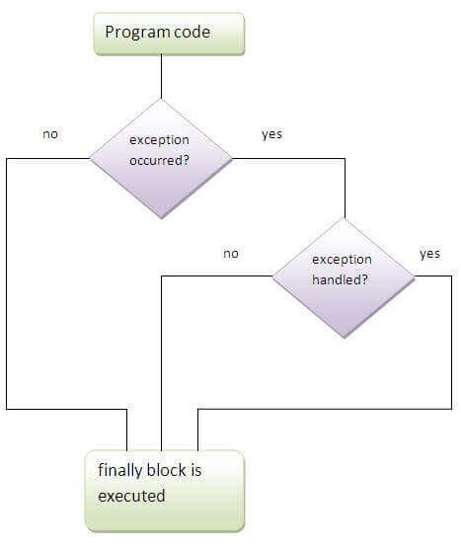

Note: If you don't handle exception, before terminating the program, JVM executes finally block(if any).

Why use java finally

* Finally block in java can be used to put "cleanup" code such as closing a file, closing connection etc.

Usage of Java finally

Let's see the different cases where java finally block can be used.

Case 1

Let's see the java finally example where **exception doesn't occur**.

1. **class** TestFinallyBlock{
2. **public** **static** **void** main(String args[]){
3. **try**{
4. **int** data=25/5;
5. System.out.println(data);
6. }
7. **catch**(NullPointerException e){System.out.println(e);}
8. **finally**{System.out.println("finally block is always executed");}
9. System.out.println("rest of the code...");
10. }
11. }

**[Test it Now](http://www.javatpoint.com/opr/test.jsp?filename=TestFinallyBlock" \t "_blank)**

Output:5

finally block is always executed

rest of the code...

Case 2

Let's see the java finally example where **exception occurs and not handled**.

1. **class** TestFinallyBlock1{
2. **public** **static** **void** main(String args[]){
3. **try**{
4. **int** data=25/0;
5. System.out.println(data);
6. }
7. **catch**(NullPointerException e){System.out.println(e);}
8. **finally**{System.out.println("finally block is always executed");}
9. System.out.println("rest of the code...");
10. }
11. }

**[Test it Now](http://www.javatpoint.com/opr/test.jsp?filename=TestFinallyBlock1" \t "_blank)**

Output:finally block is always executed

Exception in thread main java.lang.ArithmeticException:/ by zero

Case 3

Let's see the java finally example where **exception occurs and handled**.

1. **public** **class** TestFinallyBlock2{
2. **public** **static** **void** main(String args[]){
3. **try**{
4. **int** data=25/0;
5. System.out.println(data);
6. }
7. **catch**(ArithmeticException e){System.out.println(e);}
8. **finally**{System.out.println("finally block is always executed");}
9. System.out.println("rest of the code...");
10. }
11. }

**[Test it Now](http://www.javatpoint.com/opr/test.jsp?filename=TestFinallyBlock2" \t "_blank)**

Output:Exception in thread main java.lang.ArithmeticException:/ by zero

finally block is always executed

rest of the code...

Rule: For each try block there can be zero or more catch blocks, but only one finally block.

Note: The finally block will not be executed if program exits(either by calling System.exit() or by causing a fatal error that causes the process to abort).